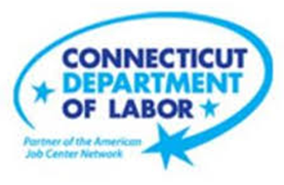

**NEW WEEKLY JOB POSTINGS FROM   
HELP WANTED ONLINE  
Office of Research**

**Week Ending October 17th, 2020   
Total New Jobs Ads Above 4,900 for Second Straight Week**

WETHERSFIELD, October 22, 2020 – During the week ending October 17, 2020, there were 4,920 new postings. New postings are up 4 new ads from a week ago and up 175 from four weeks ago. This small weekly change overlays larger industry level shifts. Increasing industries include Finance and Insurance (+95 new ads or +25%), Professional, Scientific, & Technical Services (+86 new ads or +41%), and Manufacturing (+43 new ads or +35%). Industries with large decreases include Healthcare and Social Assistance (-172 new ads or -19%) and Educational Services (-69 new ads or 32%).

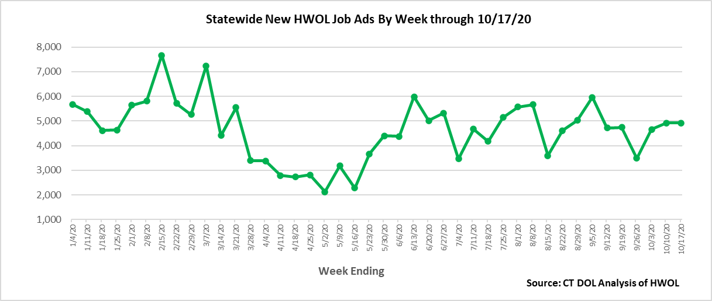

**Industries** with the most new postings include Retail Trade, Health & Social Assistance, and Finance & Insurance.

**Occupations** with the most new postings include Retail Salespersons, Software Developers, Applications, and Registered Nurses.

**Employers** with the most new postings include State of Connecticut, Cigna Corporation, and Amazon.

**The three industries with the most new job postings where**

* **Retail Trade** (774 new postings, +1% over the week)
* **Health Care and Social Assistance** (749 new postings, -19% over the week)
* **Finance and Insurance** (470 new postings, +25% over the week)

 12 sector had job posting increases over the week and 9 had decreases. Some of the largest percent increases occurred in Construction (+77% or +33 new ads), Professional, Scientific & Technical Services (+41% or +86 new ads), and Wholesale Trade (+32% or +10 new ads). The 9 decreasing industries fell by a combined 347 ads over the week. Among decreasing industries, 49.6% occurred in Health Care and Social Assistance (-19% or -172 new ads).   
  
  
For more information on total job ads by industry for Connecticut and its labor market areas, see the monthly report available here: <https://www1.ctdol.state.ct.us/lmi/hwol.asp>

The June 2020 edition of the Connecticut Economic Digest features an article on HWOL: <https://www1.ctdol.state.ct.us/lmi/digest/pdfs/cedjun20.pdf>

**New Job Postings by Occupation**

**The occupations with the most new postings were:**

* Retail Salespersons (229 new postings, +2% over the week)
* Software Developers, Applications (174 new postings, +145% over the week)
* Registered Nurses (153 new postings, +24% over the week)



**Employers with the Most New Job Postings** 

Employers with the most new job postings for the week ending October 17th were mostly in Retail Trade, Finance & Insurance, and Health Care. The 25 employers shown above account for 22 percent of all new ads. The employers with the largest increase over the week were Amazon (+49 new ads), Petco (+37 new ads) and CVS Health (+35 new ads). Three of the top 25 employers had decreases over the week, the largest being Hartford Healthcare (-59 new ads) and Lowe’s (-59 new ads).

**Covid-19 and Weekly New Job Postings**  
In recent months, the pandemic Coronavirus (Covid-19) has caused significant social and economic implications throughout the world.  
  
This HWOL report includes new weekly job postings to illustrate how Covid-19 has impacted Connecticut in the short term and highlight recent job postings in the weeks since the virus disrupted both the economy and labor markets.  
  
**What is HWOL?**The **Conference Board Help Wanted Online**® Data Series (HWOL) measures the number of new, first-time Online job postings and jobs reposted from the previous month for over 16,000 Internet job boards, corporate boards and smaller job sites that serve niche markets and smaller geographic areas. **To view more HWOL data, go to:** [**https://www1.ctdol.state.ct.us/lmi/pubs/HWOL2020.pdf**](https://www1.ctdol.state.ct.us/lmi/pubs/HWOL2020.pdf)